Freedom Conference 2025
The Environment of the Soul
Building Community through Spiritual Mastery
Leadership Roundtable

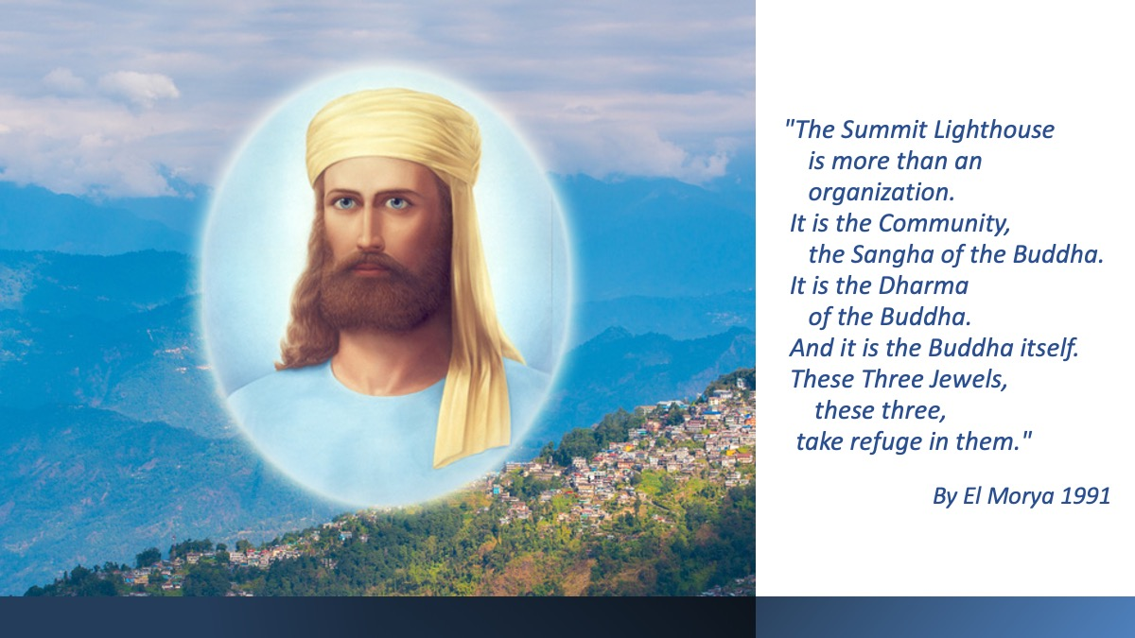
Handouts
Agenda | Page 2
Appreciative Inquiry Exercise | Page 3
Creating a Chart of TSL Benefits Exercise | Page 4
Upcoming | Page 5
Song 18: Jubilate’ | Page 6

Leadership Roundtable Agenda – [Date]
TIME | TOPIC
9:30 | OPENING INVOCATION by Rev. Kenneth Frazier
9:35 | WELCOME by Rev. Tani Kingston
9:40 | PRESENTATIONS and FACILITATION by Deborah Lynch and Glaston Ford
9:45 | EXERCISE ONE: GREETING EACH OTHER … (5 minutes)  - Share with someone you don’t know well.  - Zoom: You will be invited to a room with another person
10:00 | TOPIC 1: APPRECIATIVE INQUIRY OVERVIEW by a Guest Speaker (30 min.)
10:30 | EXERCISE TWO: NURTURING COMMUNITY (25 min.)  - Reflect: Take a moment and reflect on your answer to the question.  You may want to write a few notes on your index card or your computer.  - Share: Next take turns in your circle of four, so each person has an opportunity  to answer the question and also enjoy listening to each other.  - Notetaker: Writes the key themes on a notecard.  for Online Friends, type into the online form (the link is in the chat).  - Share your results with the Facilitator (KAC) and Use form link in chat (Zoom)
10:55 | SHARING (10 min.)  - Stand up and pair off with somebody not in your group and share.  What did you learn that may be useful in nurturing your local community (personal life?)
11:05 | BREAK with beverages (10 min.)  - After the break, please return to a new group of four
11:20 | TOPIC 2: CREATING A CHART FOR HOW TSL BENEFITS SEEKERS & MEMBERS (5 min.)
11:25 | EXERCISE THREE: SHARING BENEFITS TSL OFFERS SEEKERS & MEMBERS (45 min.)  Breakout Group 1  - Reflect: Take a moment and reflect. List 4 to 8 personal benefits that you experience from TSL. (5 min.)  - Share: Each person shares and explains 1 benefit and then the next person shares and so on (not repeating what has already been shared). If time allows, keep going around until the activity closes.  - Notetaker: Writes 1 benefit and keep adding until time is called.  - Share your results with the Facilitator (KAC) and Use form link in chat (Zoom)  Breakout Group 2  - Share – Notetaker from Group 1 shares notes from previous group. New group members add anything additional from their previous groups  Online: Take turns sharing 1 benefit from previous group and continue  - Select & Record – Whole group identifies & underlines top 3 important benefits.  - Share results – with facilitator & online form
12:10 | GROUP SHARING (10 min.)
12:20 | ANNOUNCEMENTS – What’s Next  SURVEY – Online and In Person  SONG 18: Jubilate! Let Thy Kingdom Fair, O Father
EXERCISE 2
An Appreciative Inquiry
What Makes a Community of the Holy Spirit?
TSL Experiences  Think of times when you felt proud, connected, engaged and uplifted by participating in your  local Summit Lighthouse group.  Share in some detail about these experiences.  • What makes them stand out?  • What do others do to make  them possible?  •. What do you do?  • What is the impact on you? | Your TSL Connection  • Teaching Center  • Study Group  • The Inner Retreat  • Book Group  • The Essentials Program  • Attending Quarterly Conferences  • Online
EXERCIZE 2: Form a Group of Four People
- Step one: REFLECT
Reflect on a few community experiences that have stood out.
- Step two: SHARE
Take turns sharing your stories in some depth. People can ask
questions to clarify what made the experiences possible.
3. Step three: SYNTHESIZE AND RECORD
After listening to all four peoples, make a list of key points people found
to be most important to forming a community of the holy spirit.
4. Step four: HAND IN RESULTS
Share results with a facilitator. Online post in the form.

Creating a Chart for How TSL Benefits Seekers & Members
What are 4 to 8 personal benefits that
you experience from The Summit Lighthouse?
BREAKOUT GROUP 3 – Form a Group of 4 People
- Step one: REFLECT
Reflect on 4 to 8 benefits that you have experienced from TSL.
- Step two: SHARE
Take turns sharing and explaining 1 benefit and then the next person shares 1 and so on (not repeating what has already been shared).
- Step three: SYNTHESIZE AND RECORD
Write down each benefit and keep adding until time is called.
4. Step four: HAND IN RESULTS
Share results with a facilitator. Online post in the form.

BREAKOUT GROUP 4 – Form a New Group of 4 People
- Step one: SHARE – Notetaker from Group 1 shares notes from previous group. New group members add anything additional from their previous groups
Online: Take turns sharing 1 benefit from previous group and continues until time ends.
- Step two: SELECT & RECORD – Whole group identifies and underlines top 3 most important benefits.
- Step three: SHARE RESULTS – with facilitator & online form

UPCOMING 
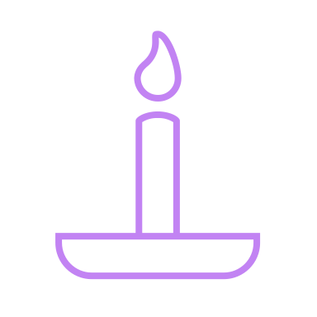 Outcomes from our Leadership Roundtable will be mailed to Keepers of the Flame. A month-long window will be open for you to review the list and share your thoughts.
Welcoming & Engaging Seekers in Your Summit Lighthouse Groups
In these three workshops you will:
- Learn the essentials to prepare, contact, engage, integrate,
and retain seekers and members in your community.
- Hear success stories from other leaders.
- Be inspired to fulfill the masters divine plan in your community.
- Learn how to be the Divine Mother in action for the new millennial seeker of truth.
Facilitated by: Deirdre Burrell, Spiritual Community Developer
- Thursday 6:30 p.m. MDT August 21st, 2025
- Thursday 6:30 p.m. MDT September 4th, 2025
- Thursday 6:30 p.m. MDT, October 2nd, 2025
To Register: www.tslcommunity.org/welcoming

Upcoming Leadership Roundtable Virtual Discussions
- Look for an invitation in the late autumn or early winter.
- If there is a topic that you believe will be most helpful for your group, please email your suggestion to dblynch@tsl.org

Thank you for sharing your Presence with us!

